AQUILA AT01 (A21

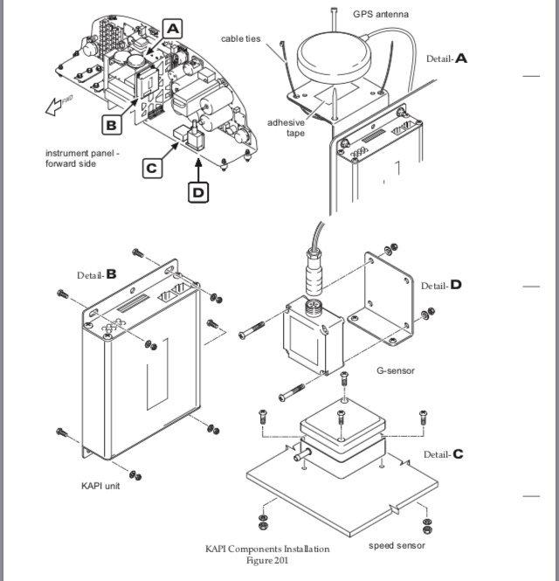

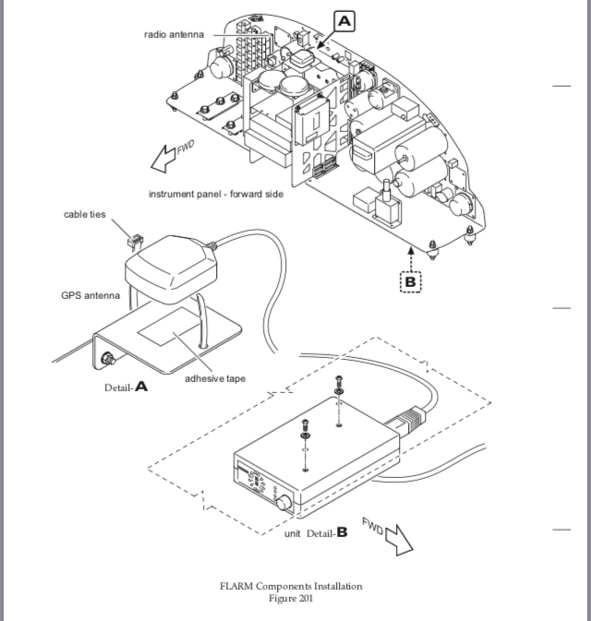

GPS ANTENNA INSTALLATION

1. Put gasket and antenna from outside,
2. Install washers and nuts securing antenna to fuselage. Simultaneously connect ground cable to backing plate.
3. Seal the antenna and gasket to fuselage using a good quality electrical sealant (Sikaflex-221 or equivalent, silicone-free).
4. Connect antenna cable.
5. Close baggage compartment door and install access / inspection plate 211 KC (refer to 25-12-00).

SLING 2

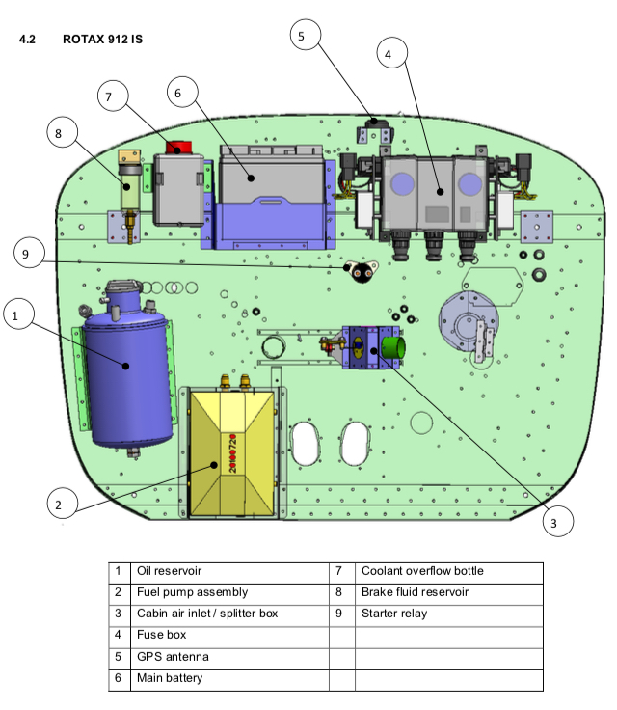

* The GPS antenna is mounted in the engine compartment on a bracket attached to the firewall.

